Dis-Eur-Czech Republic**-**Venus-Těšetice-Kyjovice 2

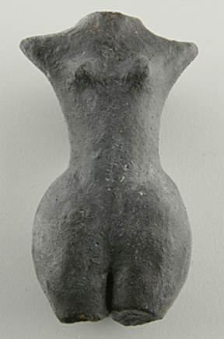

**Formal Label: Czech Republic Venus** Těšetice-Kyjovice 2

**Accession Number: A132**

**LC Classification:** DB550 .C4

**Date or Time Horizon:** **4700-4300 BCE**

**Geographical Area:** Moravia (Czech Republic)

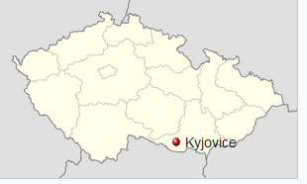 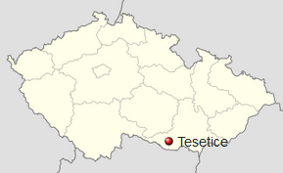

Map: [48 ° 54'50 "s. Š., 16 ° 9'59" E](https://translate.googleusercontent.com/translate_c?depth=1&hl=en&prev=search&rurl=translate.google.com&sl=cs&sp=nmt4&u=https://tools.wmflabs.org/geohack/geohack.php%3Flanguage%3Dcs%26pagename%3DKyjovice_%28okres_Znojmo%29%26params%3D48.913756085099_N_16.166516117808_E_type:city_region:CZ&usg=ALkJrhiATaLKGw4pI6U_bwaXe0Xc4T9UWg) [48 ° 53'20 "s. Š., 16 ° 9'30" E](https://translate.googleusercontent.com/translate_c?depth=1&hl=en&prev=search&rurl=translate.google.com&sl=cs&sp=nmt4&u=https://tools.wmflabs.org/geohack/geohack.php%3Flanguage%3Dcs%26pagename%3DT%25C4%259B%25C5%25A1etice_%28okres_Znojmo%29%26params%3D48.888883298132_N_16.15820181309_E_type:city_region:CZ&usg=ALkJrhhAaygmb1EGyqbXq39BwHGGMVYrQg)

**Cultural Affiliation:** Neolithic

**Medium:** Ceramic

**Dimensions: H** 65 mm; W 50 mm. **Weight:**

**Provenance:** Těšetice-Kyjovice 2

**Condition:** Museum Replica,TOP GEO, Satteldorf, Germany.

**Discussion: Těšetice-Kyjovice** is located on the border of the municipalities [Kyjovice](https://translate.googleusercontent.com/translate_c?depth=1&hl=en&prev=search&rurl=translate.google.com&sl=cs&sp=nmt4&u=https://cs.wikipedia.org/wiki/Kyjovice_%28okres_Znojmo%29&usg=ALkJrhh6MR1n35JtWyHjFrO4VKgYdZ6pQg) and [Tesetice](https://translate.googleusercontent.com/translate_c?depth=1&hl=en&prev=search&rurl=translate.google.com&sl=cs&sp=nmt4&u=https://cs.wikipedia.org/wiki/T%25C4%259B%25C5%25A1etice_%28okres_Znojmo%29&usg=ALkJrhgrrHIozC69YE2eCX5J_9iPCcGhZA) on the southern slope above the river [Únanovkou](https://translate.googleusercontent.com/translate_c?depth=1&hl=en&prev=search&rurl=translate.google.com&sl=cs&sp=nmt4&u=https://cs.wikipedia.org/w/index.php%3Ftitle%3D%25C3%259Ananovka%26action%3Dedit%26redlink%3D1&usg=ALkJrhiHJ97DkcR9YLTE7pizBgeW3EZKRg). It is a multicultural location with the beginning of a Neolithic settlement. It was discovered in 1956, explored since 1958 . Since 1967 there regularly performed systematic research sites.

**References:**

**Brno: Spisy University**, Department of Archaeology and Museology - Department of Archaeology. 2014. The history of research on "Sutnách" at Těšetice-Kyjovice [online]. Brno: [cit. 28/10/2014]. [Available online](https://translate.googleusercontent.com/translate_c?depth=1&hl=en&prev=search&rurl=translate.google.com&sl=cs&sp=nmt4&u=http://www.phil.muni.cz/waoa/home/veda/tervyz/tesetice/tes_his&usg=ALkJrhjuVZh3zLzYD0bK5ES1U4xIShcluA) .

# Podborský, Vladimir. 1985. *Těšetice-Kyjovice II.* Figurální Plastika Lidu S Moravskou Malovanou Keramikou*.* Brno: Spisy University J.E. Purkyně v Brně, Filosofická fakulta.